**Connecting to Azure PIMMIT and PIMMART Databases with Azure Data Studio**

Use the following for each environment:

**Dev** - 81-eastus2-3534-idq-sqlmi.ed262aa43bc9.database.windows.net

**Stage** - 21-eastus2-3534-idq-sqlmi.cc4c669dc8d1.database.windows.net

**Prod** - 11-eastus2-3534-idq-sqlmi.cc4c669dc8d1.database.windows.net

**APT Access:** Request the following APT request to get access.

Microsoft Azure Cloud Security Services staged rollout - password hash sync (**jcs000-az-pwdhashsync-stagedrollout**)

**Download Azure Data Studio:**

Use the link below to download the tool

<https://docs.microsoft.com/en-us/sql/azure-data-studio/download-azure-data-studio?view=sql-server-ver15>

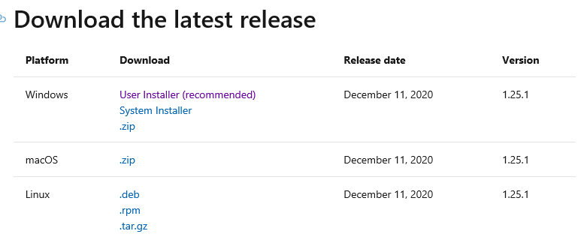

**Connecting to PIMMART and PIMMIT**

Open the tool and click on the Connection Icon on the top of the left hand panel, which brings up the Connections panel

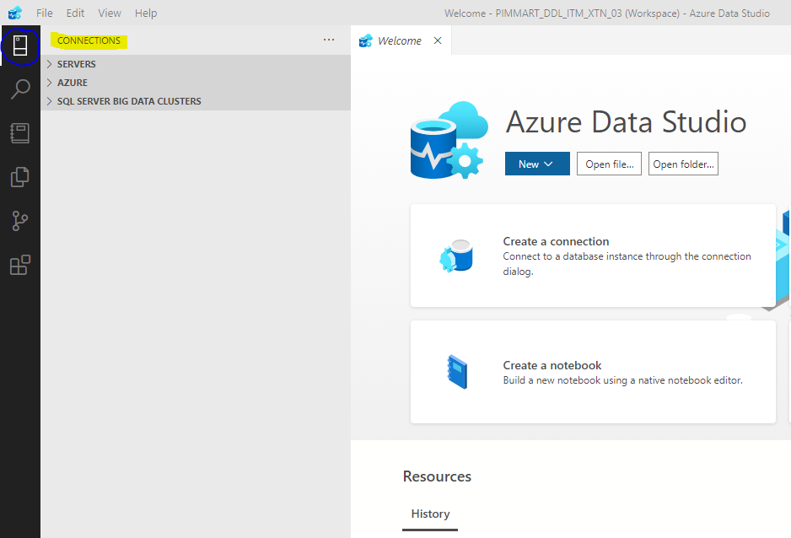

Next, click on the arrow next to the SERVERS and click on the New Connection icon

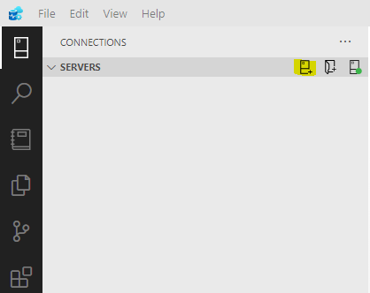

When the Connection window opens, fill it out as shown below for the PIMMART Connection:

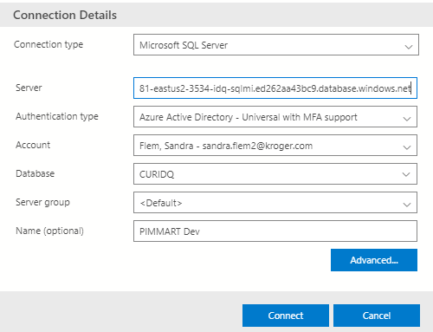

In the Account section, choose add account and it will take you to a screen to sign into your Microsoft account, so choose that and then it will be there for any additional connections. Then you can click the connect button to use the database.

Once you are connected to the database, you can click on the arrow, next to PIMMART Dev and then see the tables and views.

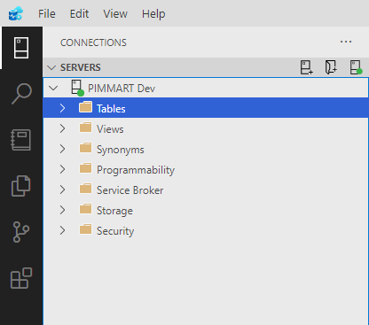

You can then click on New Query or you can use File/Open File to open queries that you have used before.

In order to access PIMMIT, create a new connection with the following fields:

